

SMART BANKING WALLET SYSTEM

Submitted By:
Rameen Ramzan — 24K-0557
Umama Zubair — 24K-0621

1. Executive Summary
This project presents the development of a Smart Banking Wallet System using C++ and the following major Data Structures:
- Linked List (Transaction History)
- Stack (Undo System)
- Priority Queue (Scheduled Payments)
- Dynamic Arrays (Users Database)
The system supports secure account creation, PIN/password login, deposits, withdrawals, transfers, undo operations, scheduled payments, and data persistence through file handling.
This project demonstrates a practical real-world application of Data Structures.

2. Introduction
Modern digital banking relies heavily on secure, efficient data handling.
This project applies core DSA concepts to create a functional banking wallet that:
- Manages user accounts
- Handles transactions securely
- Records complete history
- Allows undo within a specified time window
- Automates payments using a Priority Queue
The system is built using structured programming and object-oriented techniques in C++.

2.1 Project Objectives
- Develop a functioning banking wallet in C++.
- Apply Linked List, Stack, Priority Queue, and Dynamic Array.
- Implement secure login with PIN/password verification.
- Store full transaction history.
- Allow undo operations using Stack.
- Provide scheduled payments using Priority Queue.
- Support file persistence.
- Offer a clean, user-friendly, menu-driven interface.

3. System Description
The project simulates a real banking system, allowing users to:
- Create accounts.
- Log in securely.
- Deposit, withdraw, and transfer funds.
- Undo last transaction within 60 seconds.
- Schedule payments.
- View transaction history.
- Update profile information.
The system persists data across sessions using text files.

3.1 Scope of the Project

Included Features
- Account creation
- Login & password verification
- PIN-based transaction verification
- Deposits & withdrawals
- Fund transfers
- Undo operation (within 60 seconds)
- Scheduled payments
- Cancellation of scheduled payments
- Transaction history
- Profile updates
- File storage

4. Data Structures Used
This system is fully based on core DSA principles:

4.1 Linked List – Transaction History
Used to store transaction records dynamically.
Each node contains:
- Transaction ID
- Type
- Amount
- Balance after
- Timestamp
- Other account (optional)
Reason: Linked Lists allow fast sequential insertion and unlimited growth.

4.2 Stack – Undo System
Stores:
- Transaction amount
- Type
- Balance before
- Balance after
- Timestamp
Undo uses LIFO, making Stack ideal.

4.3 Priority Queue – Scheduled Payments
Payments are stored automatically sorted by execution time.
Executed only when due.
Reason: Priority Queue ensures earliest payment is processed first.

4.4 Dynamic Array – User Accounts
Users are stored in a dynamic array that expands automatically.

5. Methodology
- Designing class architecture
- Implementing data structures
- Coding transaction operations
- Adding scheduled payments
- Implementing security & validation
- Integrating file handling
- Testing & debugging
- Writing documentation

6. Roles and Responsibilities
Both group members contributed equally to the entire project.

Responsibilities Completed Jointly
- Designing all data structures
- Developing core functionalities
- Building user authentication and transaction logic
- Implementing undo and scheduled payments
- Debugging all modules
- Writing documentation and structuring the report

7. Project Implementation

Core Components
- User Class
Manages account data, PIN/password checks, transactions, logs.
- BankingSystem Class
Controls user login, transaction flow, payments, menus, file operations.
- TransactionLinkedList, TransactionStack, PaymentPriorityQueue
Power transaction history, undo, and automation.

Main Functionalities
- Account creation
- Login & verification
- Deposit / Withdraw
- Transfer
- Undo last transaction
- Schedule payments
- Cancel scheduled payments
- View history
- Update profile

8. Output Screeshots
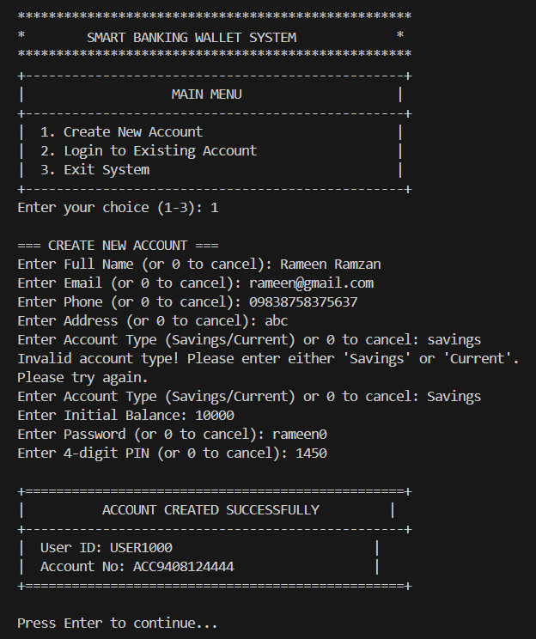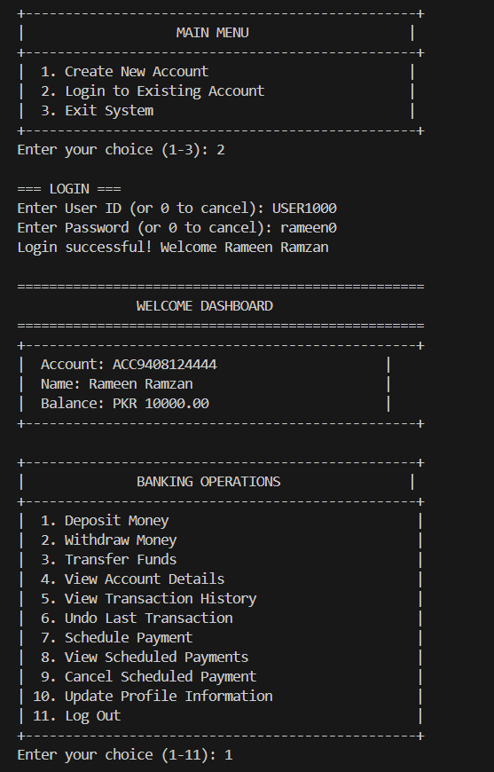
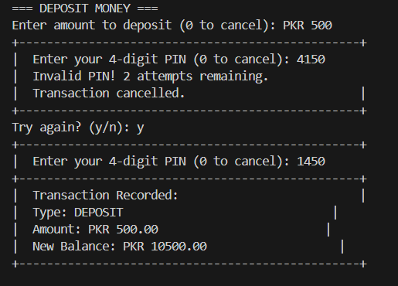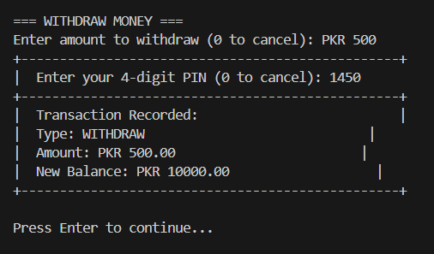
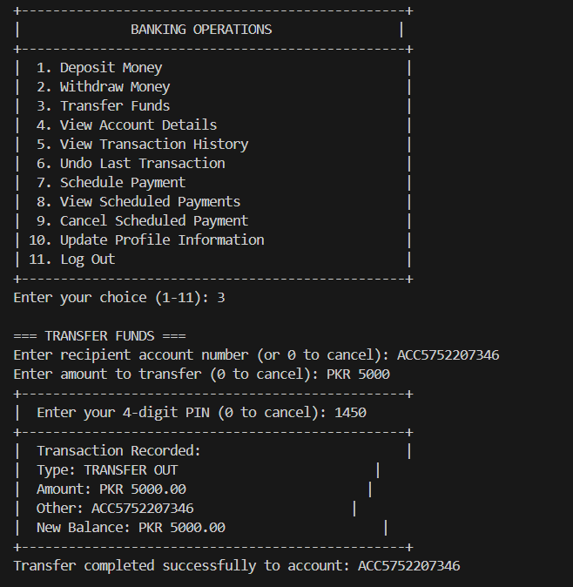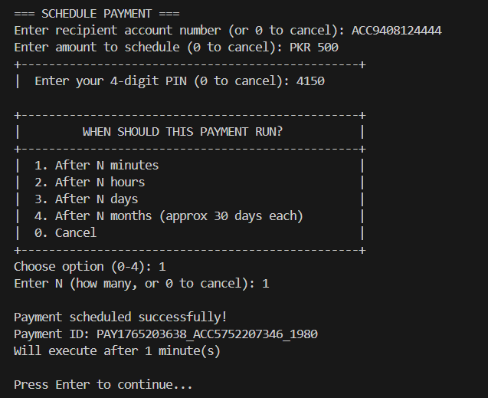
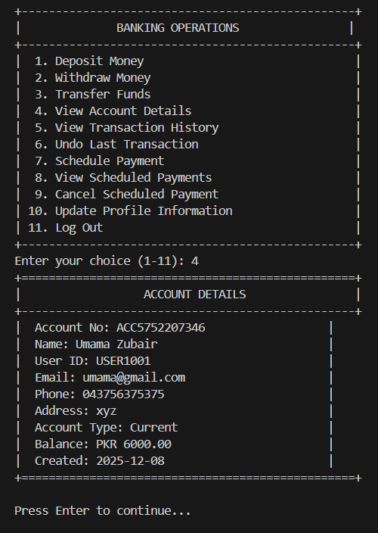

9. Results
All features were tested successfully:
- Transactions behave correctly
- Undo functions within allowed time
- Scheduled payments run accurately
- File handling works reliably
- System handles invalid input gracefully

10. Conclusion
The Smart Banking Wallet System successfully demonstrates how Data Structures can be applied to a complex real-world problem.
The project fulfills all objectives, showcasing Linked Lists, Stacks, Priority Queues, and Dynamic Arrays working together to create a powerful and scalable application.
This project stands as strong evidence of practical understanding and application of DSA principles.

